|  |  |
| --- | --- |
| **Exp No: 7**  **Date: 19.04.25** | servlet program to store using cookies |

**AIM :**

Write a Servlet program to store a user's preferences (like theme or language) using cookies. Retrieve and display these preferences on subsequent visits.

**PROGRAM:**

**COOKIE.HTML**

<!DOCTYPE html>  
<html>  
<head>  
<meta charset="ISO-8859-1">  
<title>Cookies</title>  
</head>  
<body>  
    <form method = "POST" action="cookie_index" >  
    <p>  
    <label>theme: </label>  
    <input type="text" name="theme">  
    </p>  
    <p>  
    <label for="language"> Language: </label>  
    <label for="tamil">tamil</label>  
    <input type="radio" id="tamil" name="language" value="tamil">  
    <label for="english">english</label>  
    <input type="radio" id="english" name="language" value="english">  
    <label for="hindi">hindi</label>  
    <input type="radio" id="hindi" name="language" value="hindi">  
    <label for="mandaren">mandaren</label>  
    <input type="radio" id="mandaren" name="language" value="mandaren">  
    </p>  
    <button type="submit"> Submit </button>  
  
    </form>  
</body>  
</html>

GETCOOKIE.jsp

<!DOCTYPE html>  
<html>  
<head>  
<meta charset="ISO-8859-1">  
<title>Get Cookie</title>  
</head>  
<body>  
<%  
  Cookie[] cookies = request.getCookies();  
        String cookieName = "theme";  
        String cookieNames = "language";  
        if (cookies != null) {  
            for (Cookie cookie : cookies) {  
                if (cookieName.equals(cookie.getName())) {  
                System.out.println("theme "+cookie.getName());  
                out.println(cookie.getValue());  
                }  
                if (cookieNames.equals(cookie.getName())) {  
                System.out.println("language "+cookie.getName());  
                out.println(cookie.getValue());}  
            }  
             
        }

**Cookie.java**

package com.prakash.servlet;  
  
import java.io.IOException;  
import javax.servlet.ServletException;  
import javax.servlet.annotation.WebServlet;  
import javax.servlet.http.Cookie;  
import javax.servlet.http.HttpServlet;  
import javax.servlet.http.HttpServletRequest;  
import javax.servlet.http.HttpServletResponse;  
  
/**  
 * Servlet implementation class cookie_index  
 */  
@WebServlet("/cookie_index")  
public class cookie_index extends HttpServlet {  
private static final long serialVersionUID = 1L;  
         
    /**  
     * @see HttpServlet#HttpServlet()  
     */  
    public cookie_index() {  
        super();  
        // TODO Auto-generated constructor stub  
    }  
  
/**  
* @see HttpServlet#doGet(HttpServletRequest request, HttpServletResponse response)  
*/  
protected void doGet(HttpServletRequest request, HttpServletResponse response) throws ServletException, IOException {  
// TODO Auto-generated method stub  
response.getWriter().append("Served at: ").append(request.getContextPath());  
}  
  
/**  
* @see HttpServlet#doPost(HttpServletRequest request, HttpServletResponse response)  
*/  
protected void doPost(HttpServletRequest request, HttpServletResponse response) throws ServletException, IOException {  
  
       String user = request.getParameter("theme");  
       String pass = request.getParameter("language");  
       Cookie theme = new Cookie("theme", user);  
       theme.setMaxAge(60*60);  
       theme.setPath("/");  
       Cookie language = new Cookie("language", pass);  
       language.setMaxAge(60*60);  
       language.setPath("/");  
       response.addCookie(theme);  
       response.addCookie(language);  
       response.sendRedirect("getCookie.jsp");  
  
     
     
}  
  
}

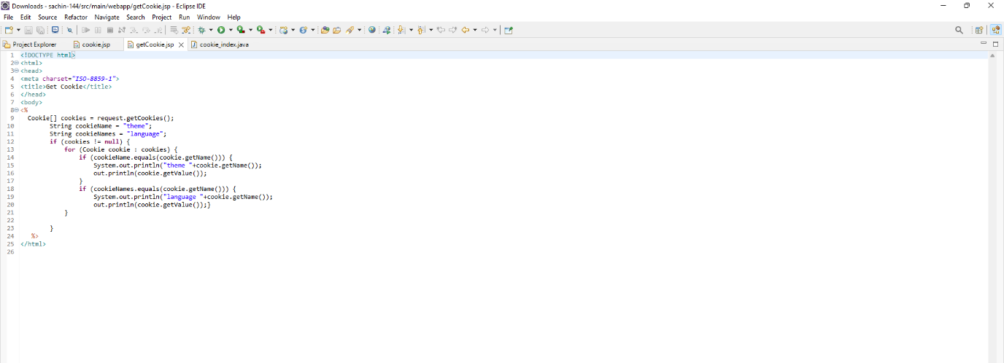

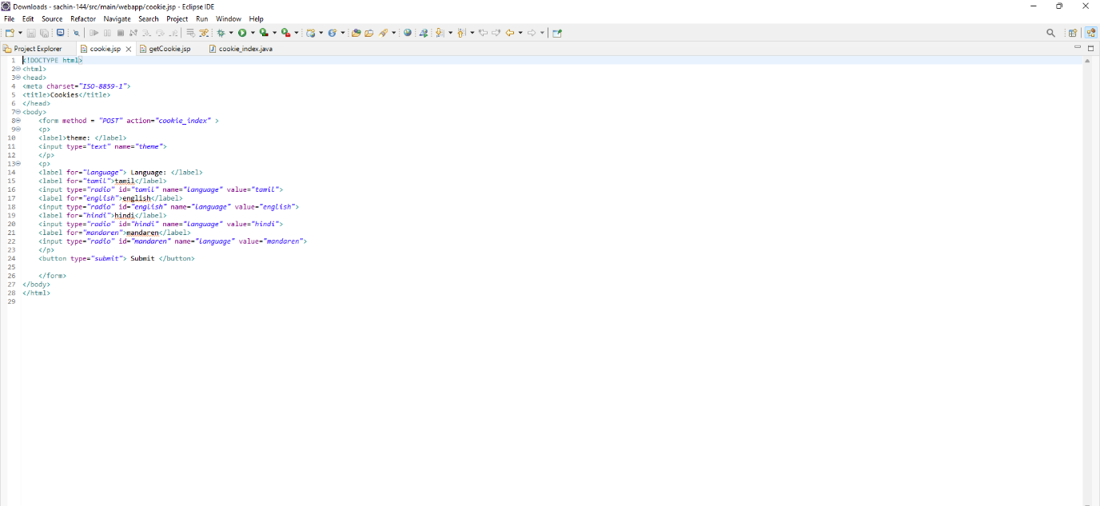

**OUTPUT:**

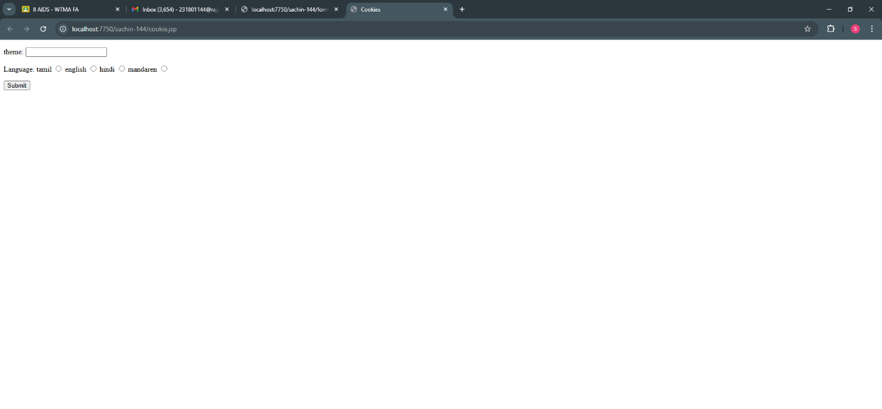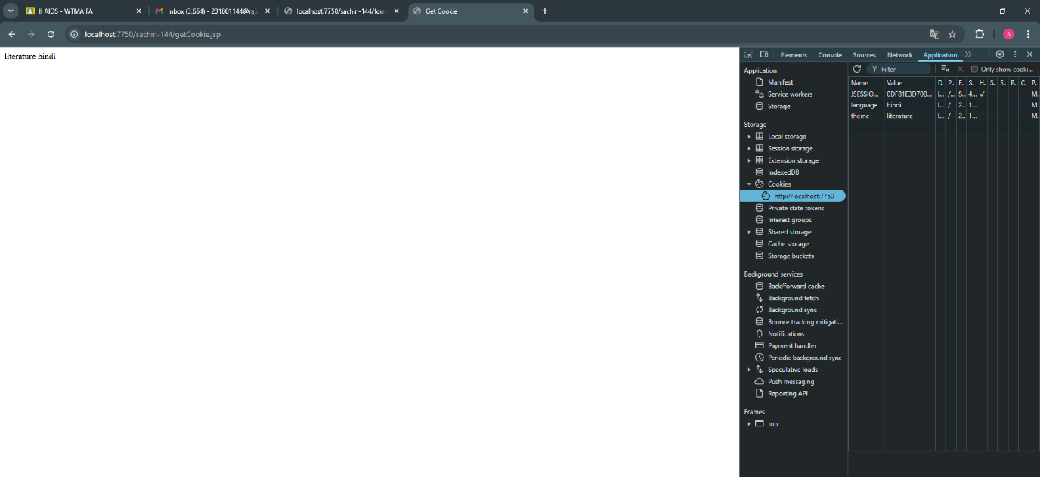

**RESULT :**Thus the experiment Write a Servlet program to store a user's preferences (like theme or language) using cookies. Retrieve and display these preferences on subsequent visits has been successfully implemented and verified